**Karnaugh maps**

**Exercise 1 –** Draw the truth tables and maps for the following functions:

Solution:

**Exercise 2 –** Construct the maps of the following functions:

Solution:

1. 
2. 

**Exercise 3 –** Minimize the logical functions in the maps below as sums of products.

1. F1:



Solution:

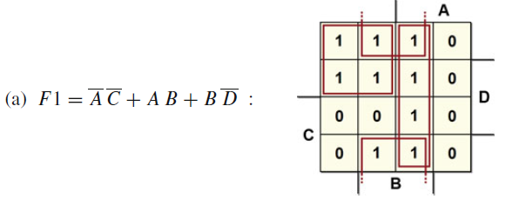

1. F2:



Solution:

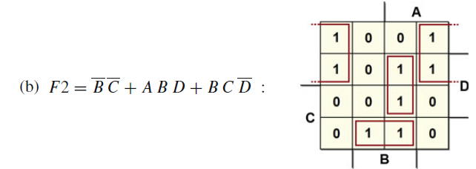

1. F3:



Solution:  
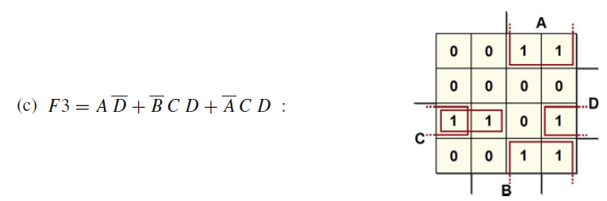

1. F4:



Solution:

**Exercise 4 –** Minimize the function as a sum of products, keeping in mind that inputs ABCD = “11−−” and ABCD = “−−11” are never present (combinations A = B = 1 or C = D = 1 can never arise).

Solution:  
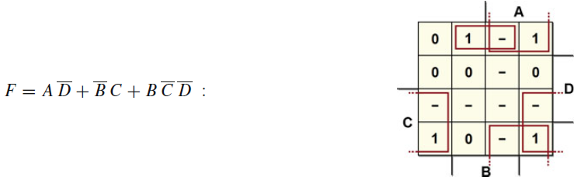

**Exercise 5 –** Synthesize the logical function in the map below as a sum of products.



Solution:

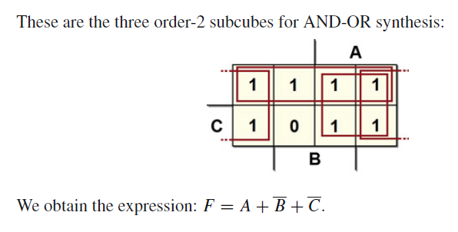

**Exercise 6 –** Synthesize the logical function in the map of the previous exercise as a product of sums.

Solution:

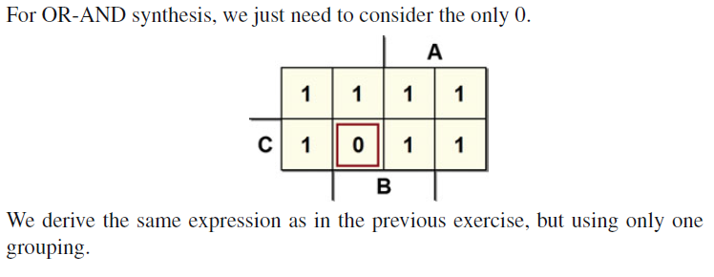

**Exercise 7 –** Synthesize the following map, which contains don’t-cares.



Solution:



**Exercise 8 –** Synthesize the following map.



Solution:  




**Exercise 9 –** Synthesize the following map and design the circuit.

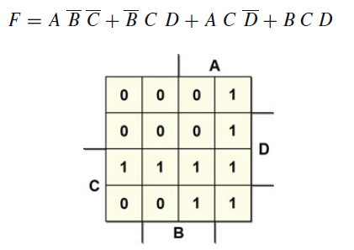

Solution:







**Exercise 10 –** Minimize each of the Boolean equations using Karnaugh maps

Equations not optimized:

Solution:

**Exercise 11 –** Write Boolean equations for the circuit in figure. You need not minimize the equation.

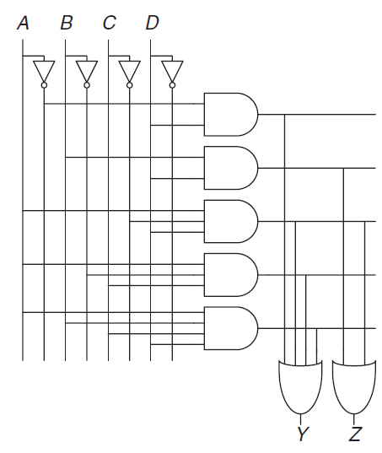

**Exercise 12 –** Minimize the Boolean equations from Exercise 11 using K-maps and sketch an improved circuit with the same function.

Solution:

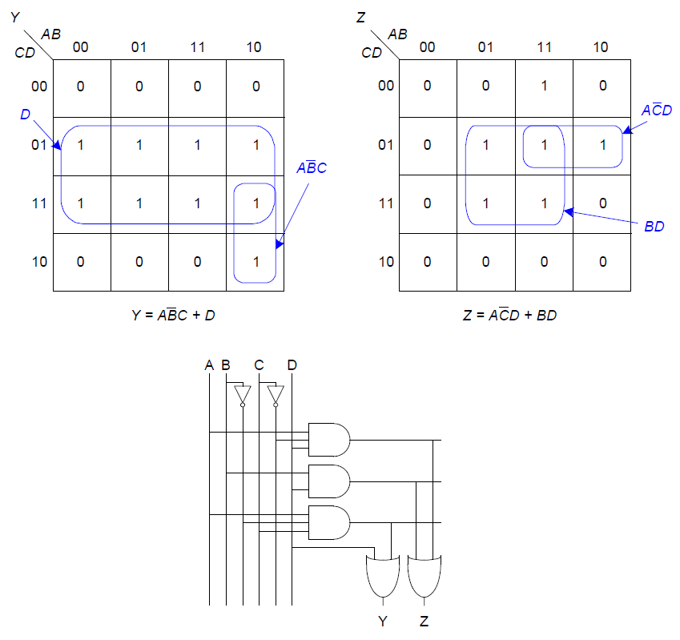

**Exercise 13 –** Find a minimal Boolean equation for the function in figure below.

Remember to take advantage of the don’t care entries.

Then sketch a circuit for the function.

Solution:

